YOUR SCHOOL’S NAME  
DIRECTED BY YOUR NAME

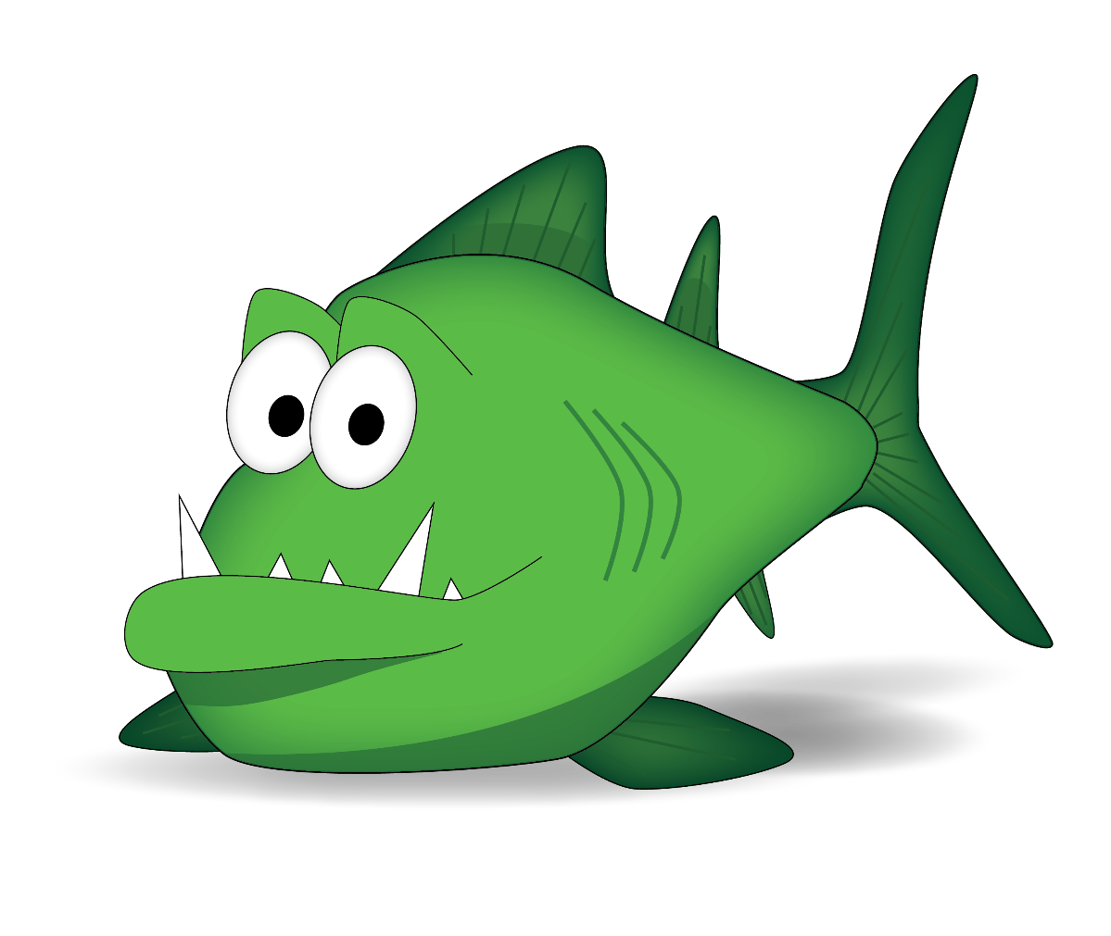

Emotional Safety Education Grant  
© 2015 all rights reserved

Deanna Rhinehart

and

Justin Morken

Emotional Safety Education Grant  
© 2015 all rights reserved

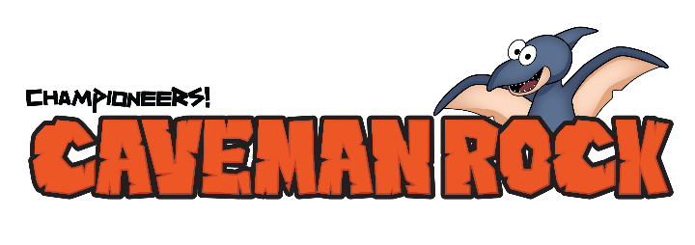

Participants

You can either list student names or classes. We prefer to list the classes for sake of time and ease. All it takes is one miss-spelled name or missed child to cause a lot of concern, but it’s your call in how you prefer to acknowledge your participants.

Teachers Name:

Student Name  
Student Name  
Student Name  
Student Name

Our school is a recipient of the Championeers! Emotional Safety Education Grant worth up to $50,000 in training and resources to develop emotionally safe schools and communities. If you would like to receive a free Caveman Family Night Adventure, text Familynight to 33444.

Include thank you notes and supporter acknowledgements here.